Author: Jacob Stauffer, CISSP, Major

National Cadet Team

Cyber Defense Training Academy

Cyber Activity Kit



# Contents

|  |  |
| --- | --- |
| Qty | Item |
| 3 | BDU cargo pants |
| 3 | Black CDTA t-shirts |
| 3 | 5.11 polo shirts |
| 3 | Baseball caps |
| 3 | Evidence kits |
| 3 | Chromebook w/ AC charger |
| 3 | Clipboard |
| 1 | Box of latex / nitrite gloves |
| 12 | CIAS Cyber Threat Defender card games |
| 10 | Cyber Defense Training Academy Challenge Coins |
| 1 | Activity binder |
| 1 | 5.11 hard case |
| 2 | Combination locks |

**SENIOR MEMBER – You are responsible for all items within this case. Any missing items will be replaced by the senior member in charge of the activity. Unit, Group, or Wing commanders will be notified if items are not replaced.**

# Activity Kit Layout

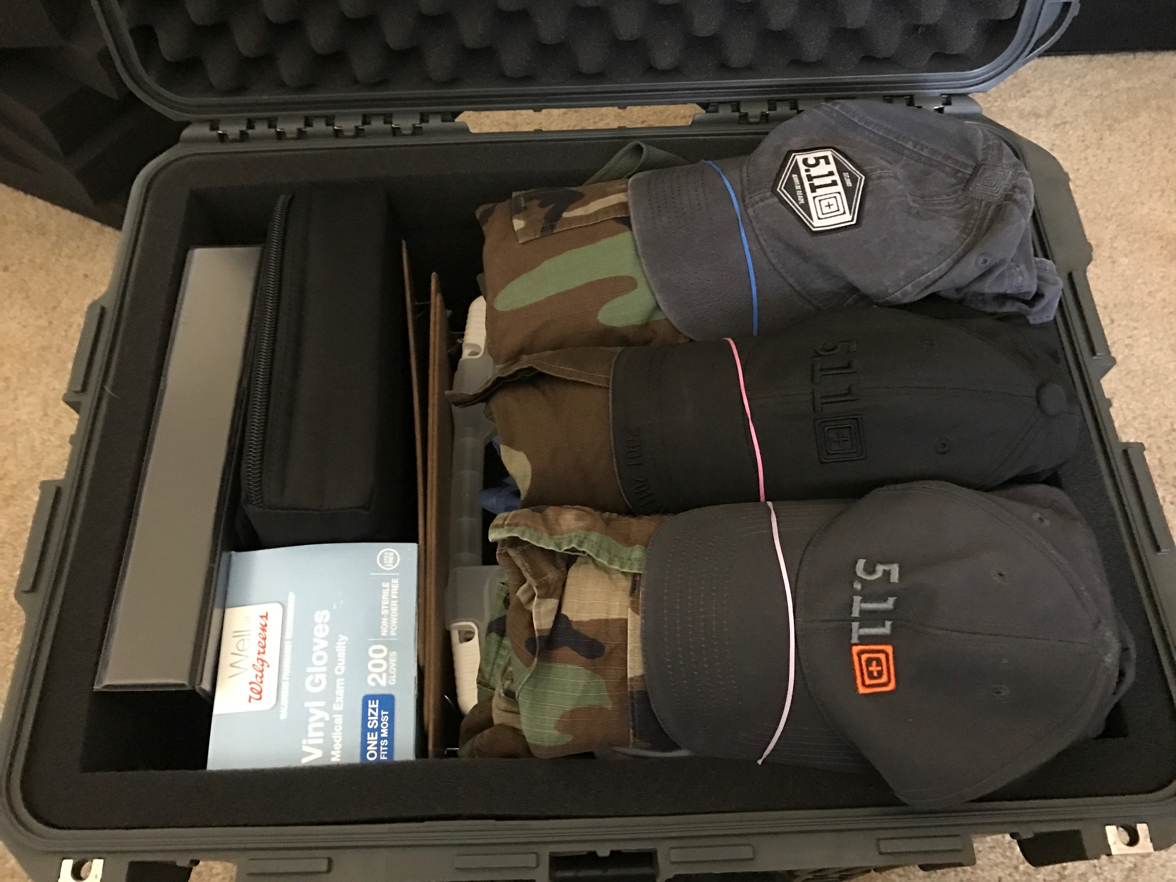

Figure 1 - Activity Kit Layout

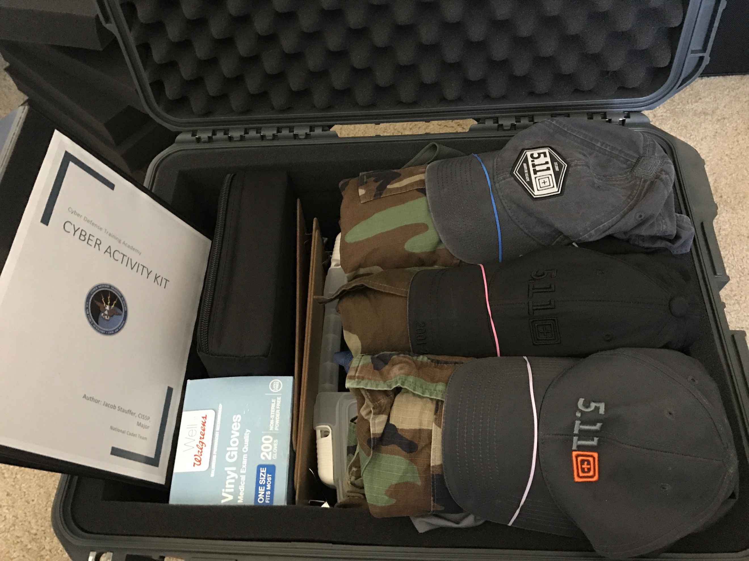

Figure 2 - Cyber Activity Kit Binder

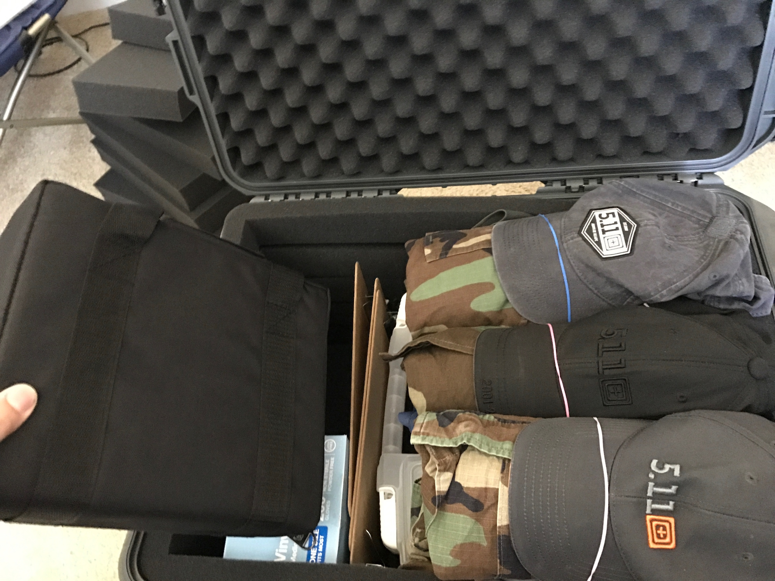

Figure 3 - Cyber Threat Defender Card Games

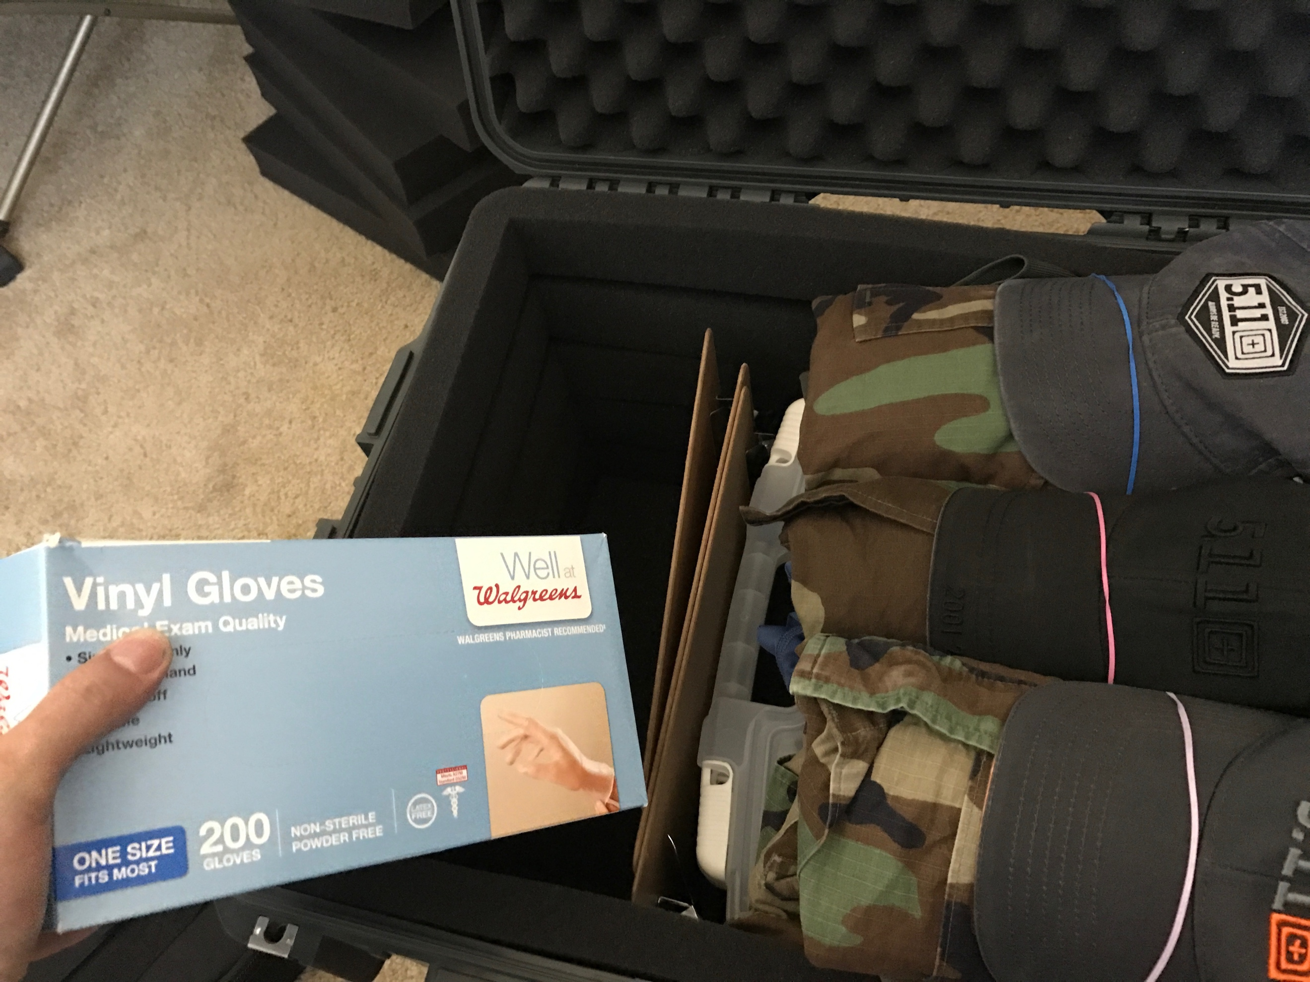

Figure 4 - Vinyl Gloves for Forensic Challenge

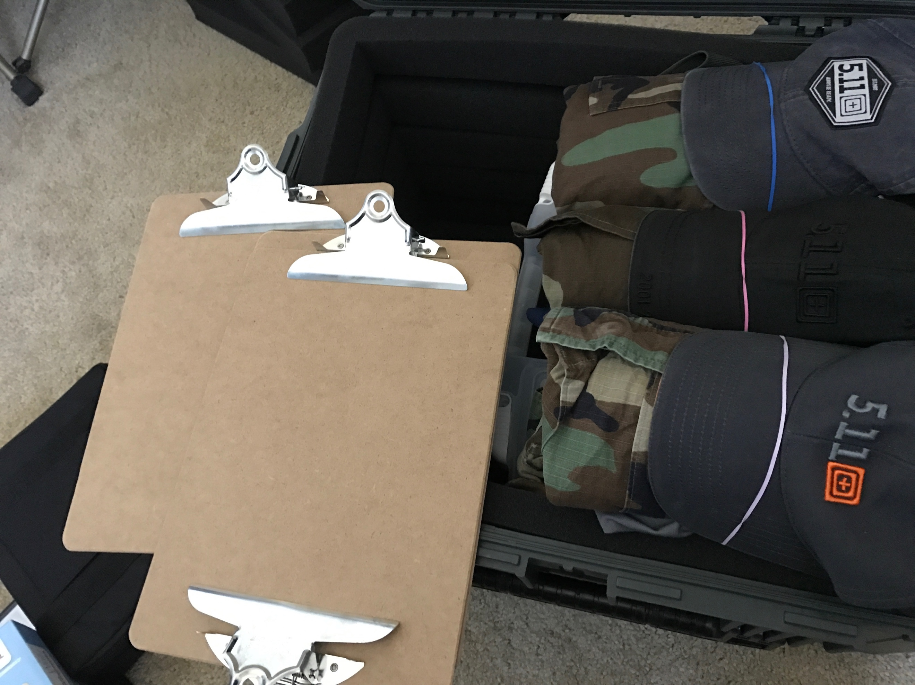

Figure 5 - Judges Clipboards

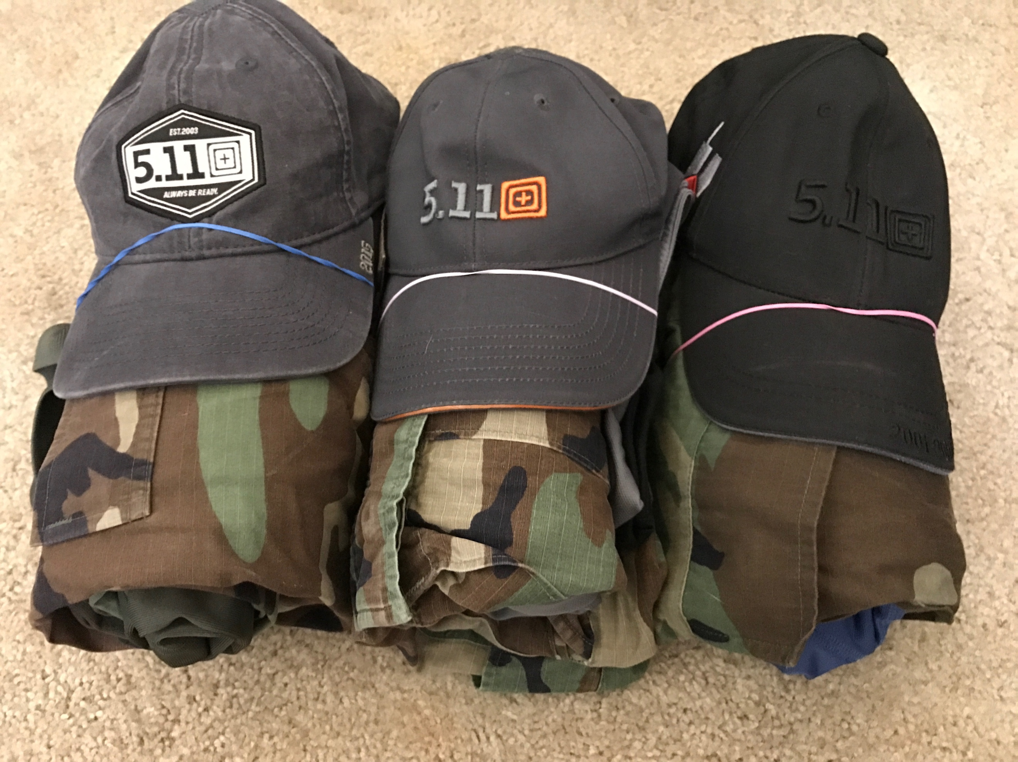

Figure 6 - Forensics Challenge Clothing (Evidence)

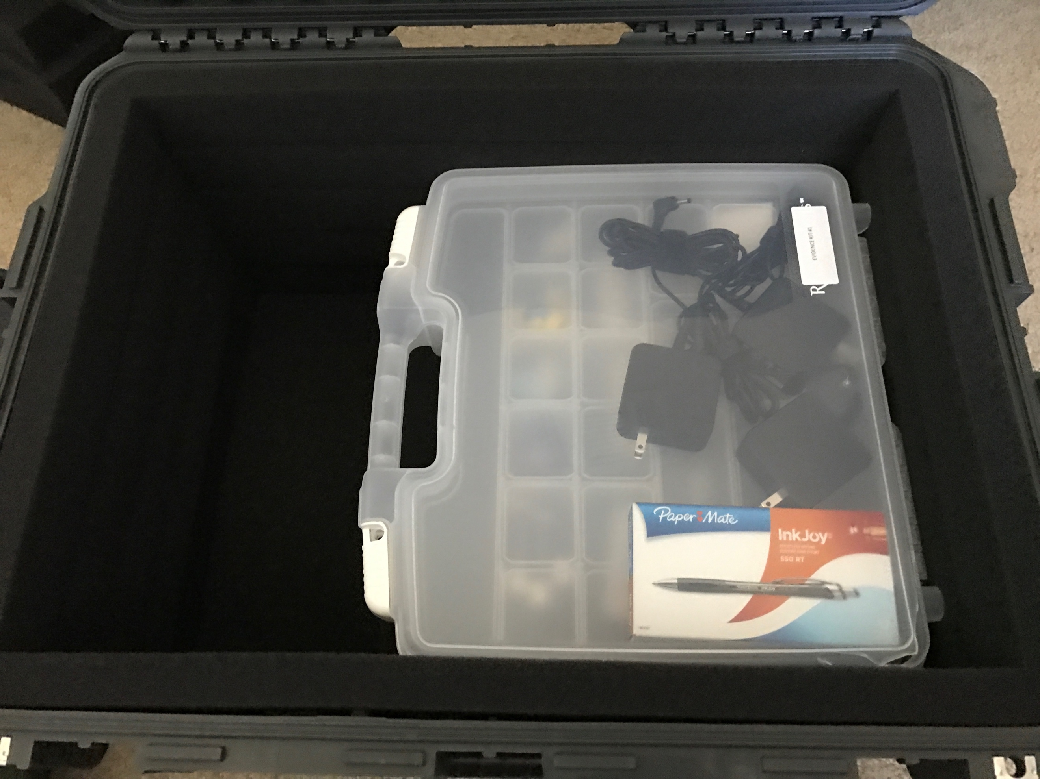

Figure 7 - Forensic Challenge Evidence Kit

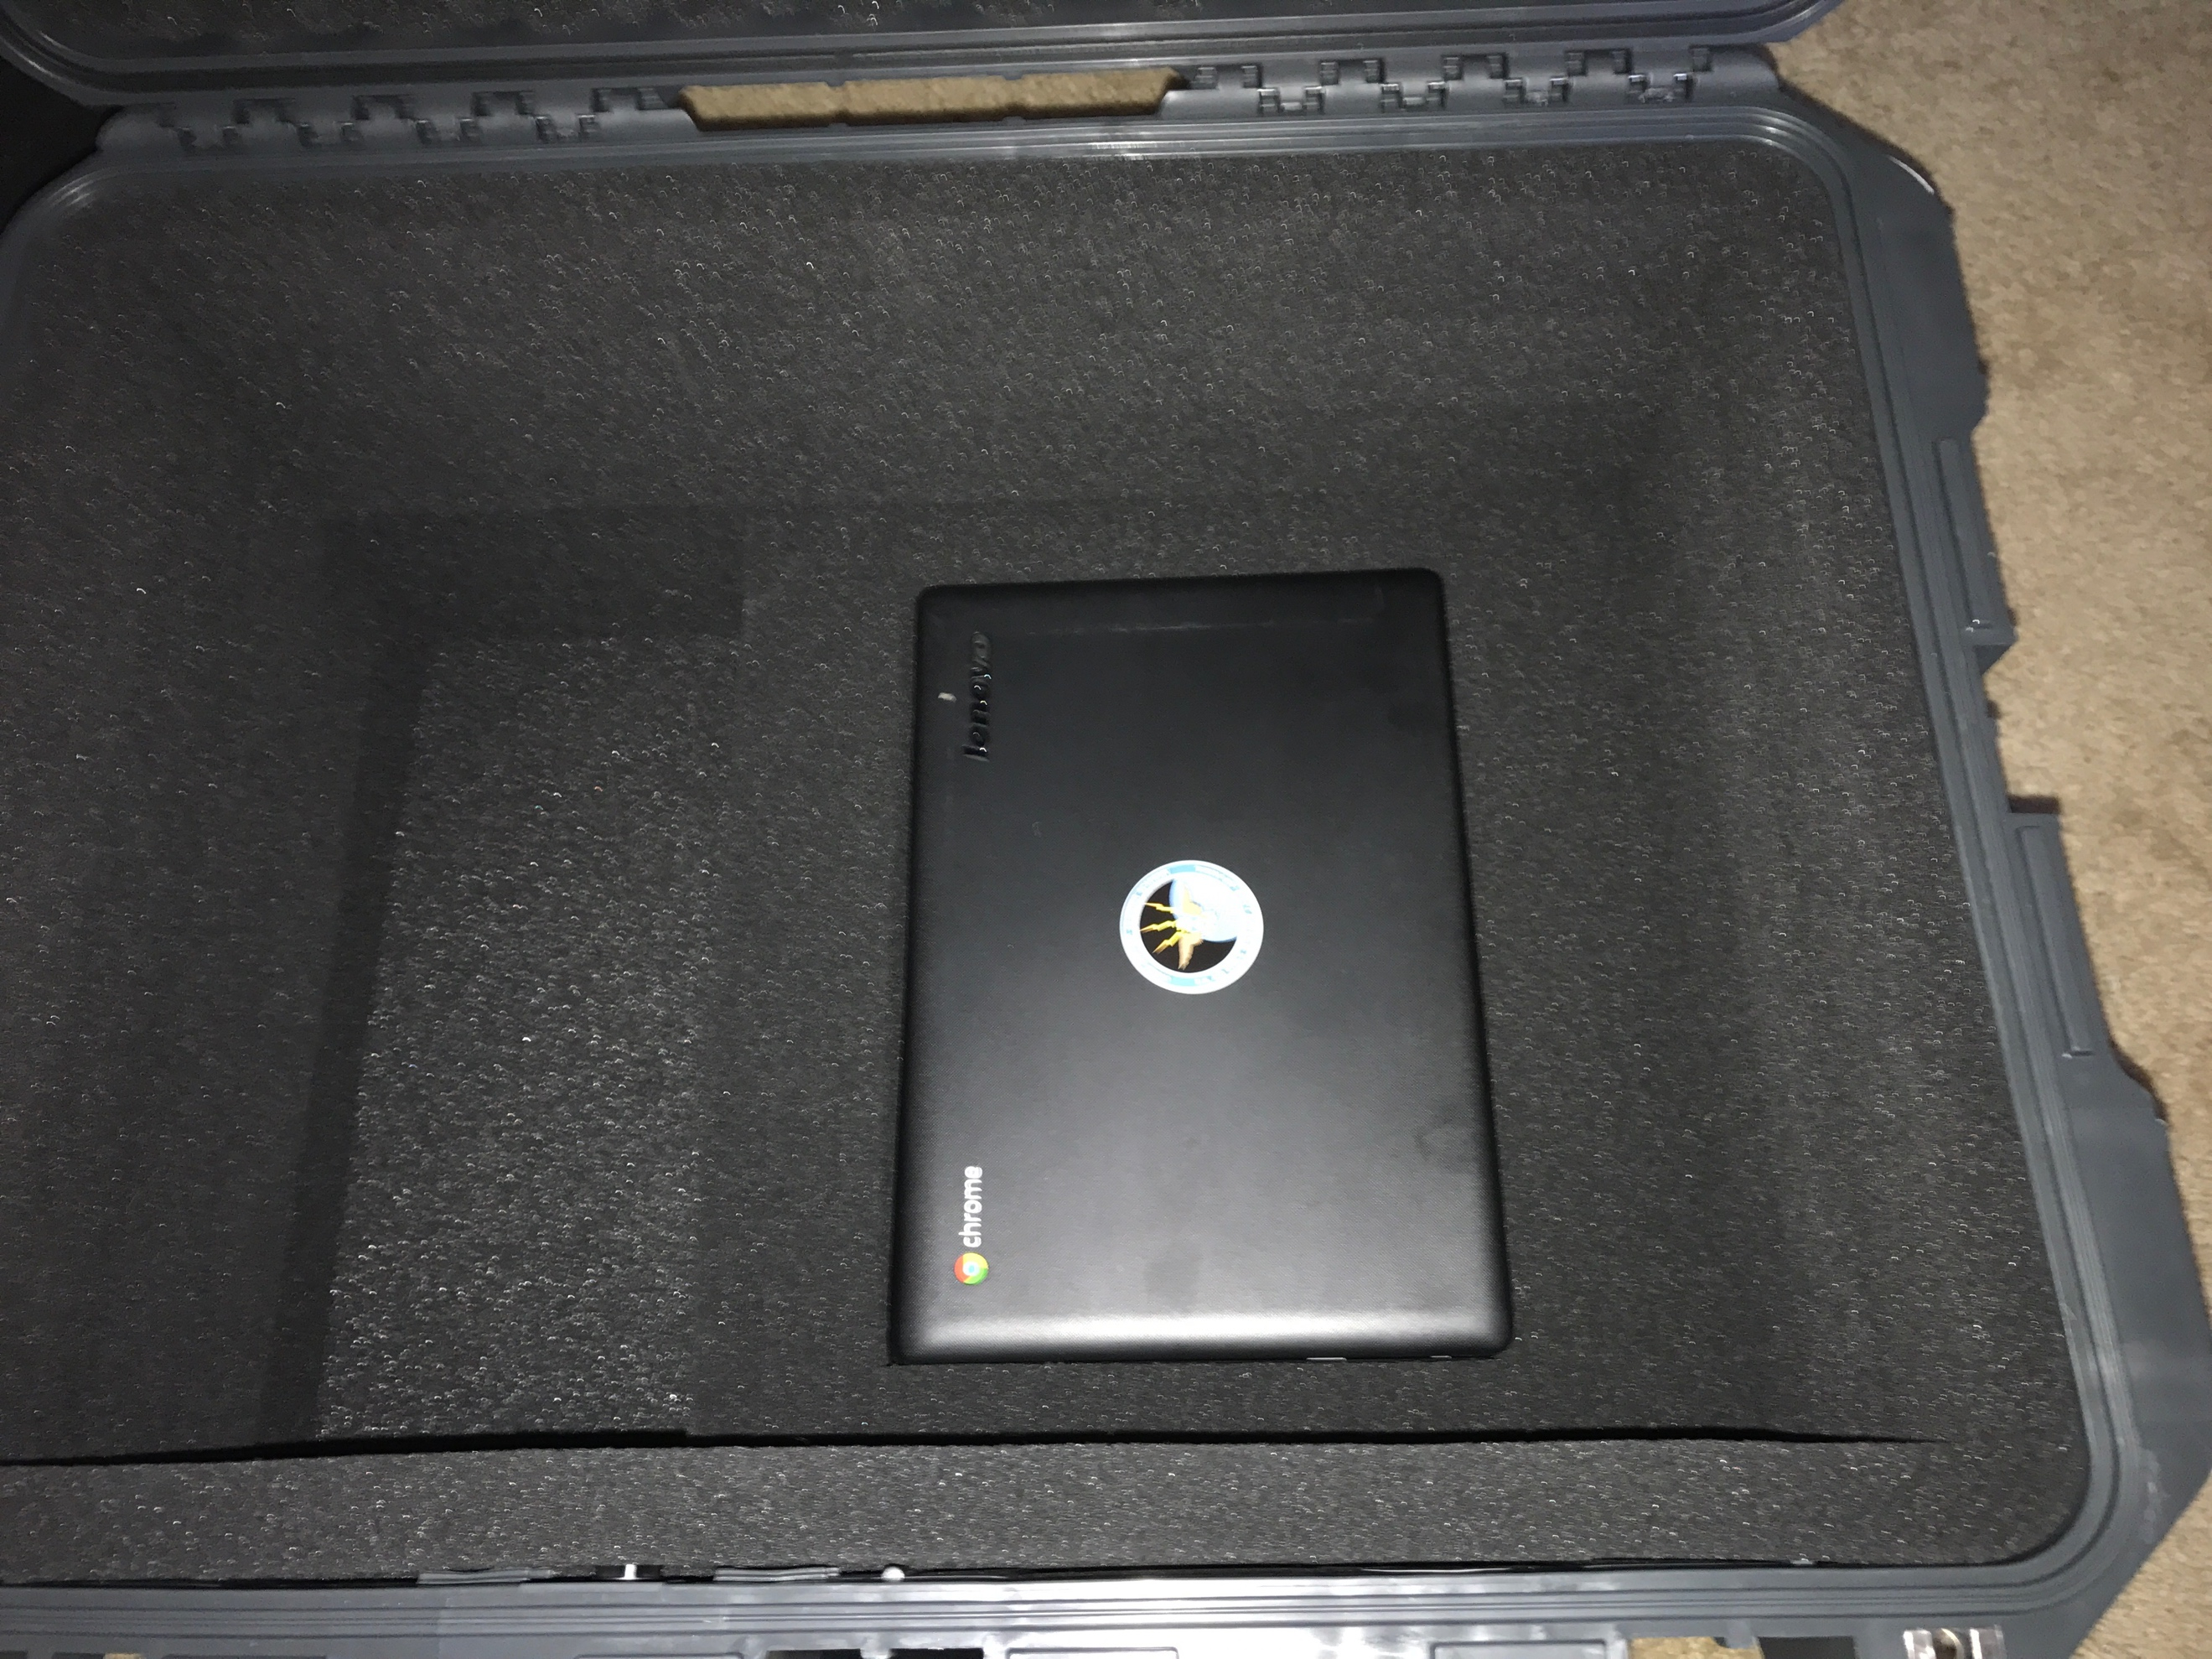

Figure 8 - Three Chromebook Laptops

# Evidence Kit Layout

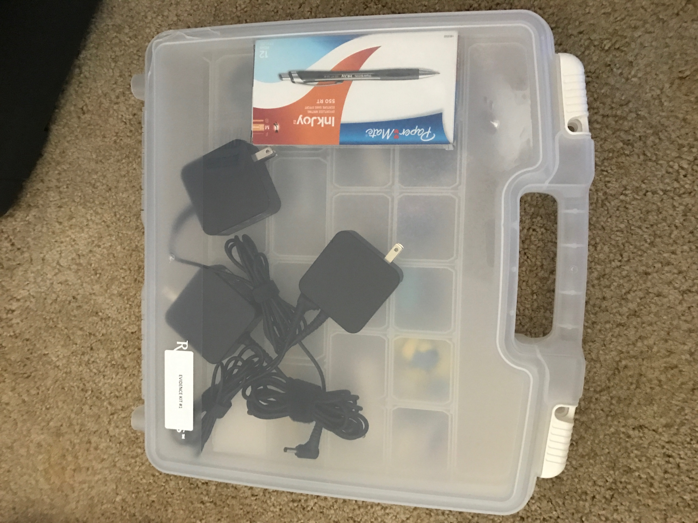

Figure 9 - Opening the evidence kit

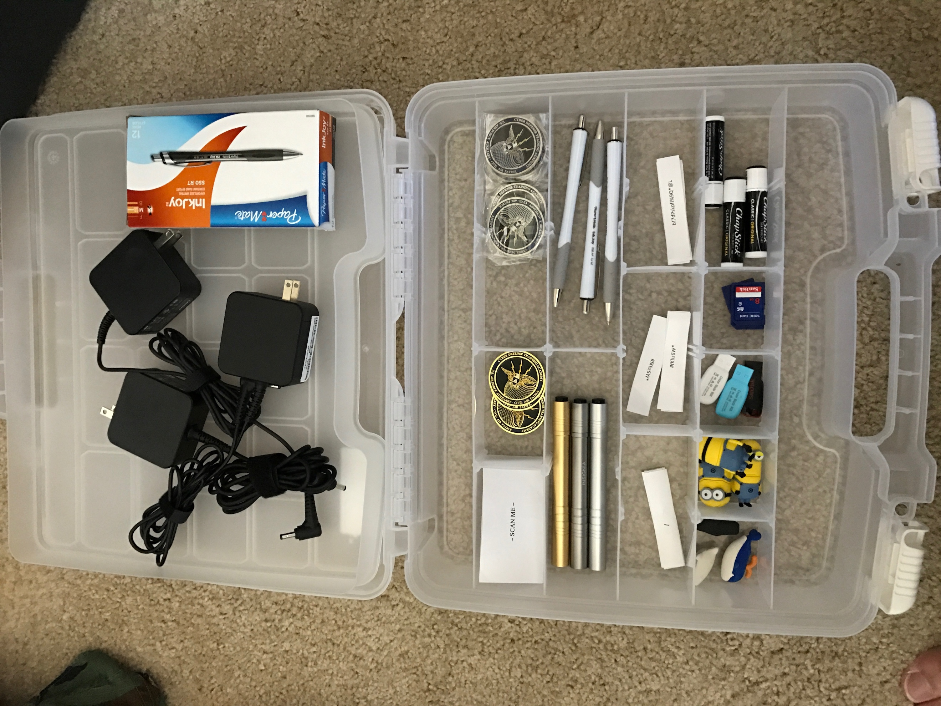

Figure 10 - Removing the top shelf

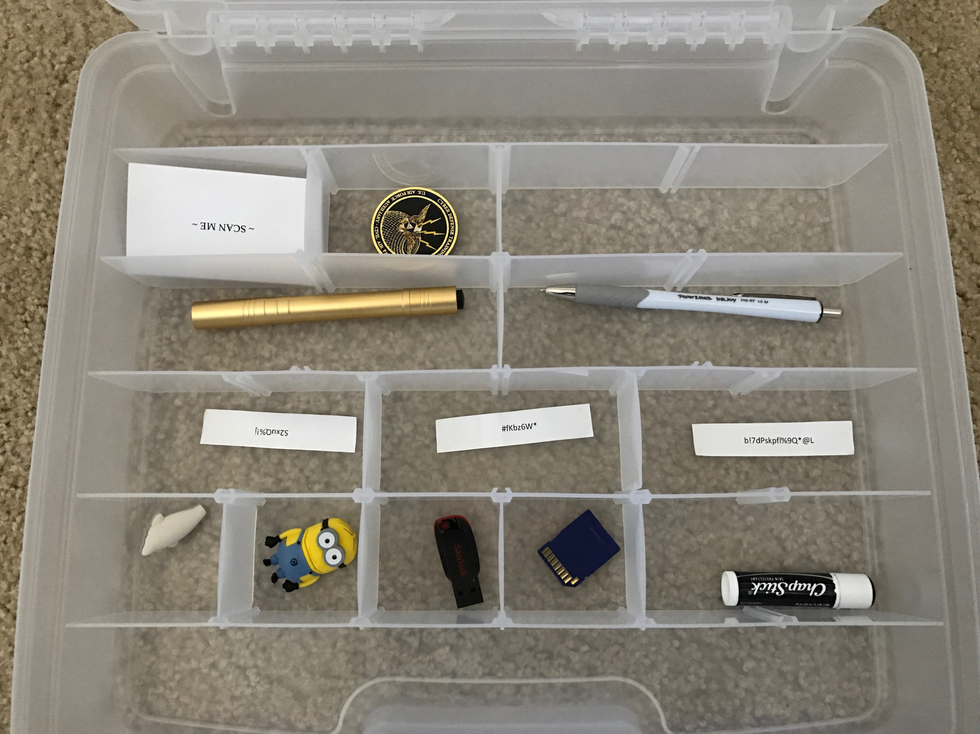

Figure 11 - ALL evidence pieces MUST be put back into this order (times 3).

# Cyber Threat Defender Game Layout

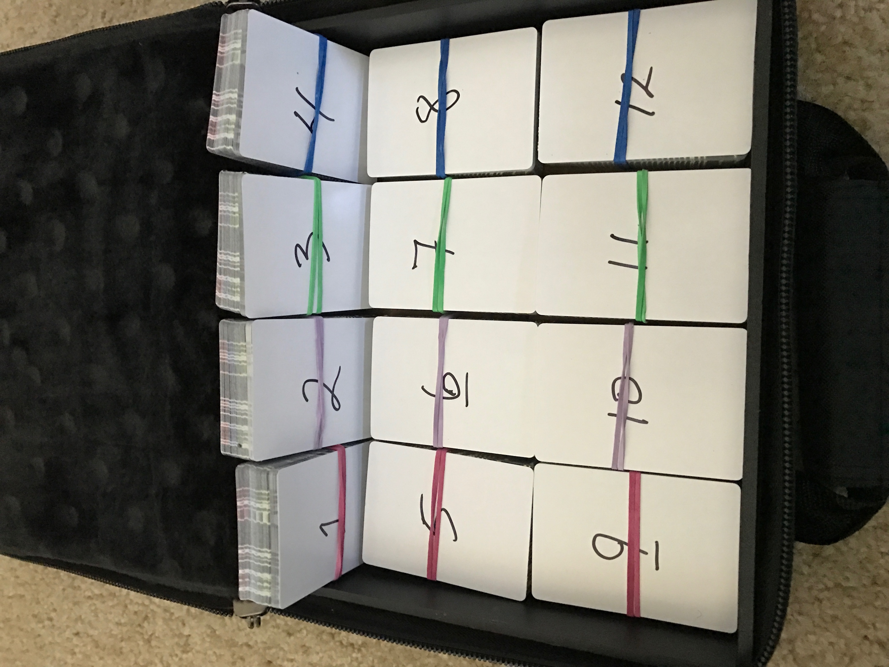

Figure 12 - Card decks w/ number cards and rubber banded

# Chromebook Setup

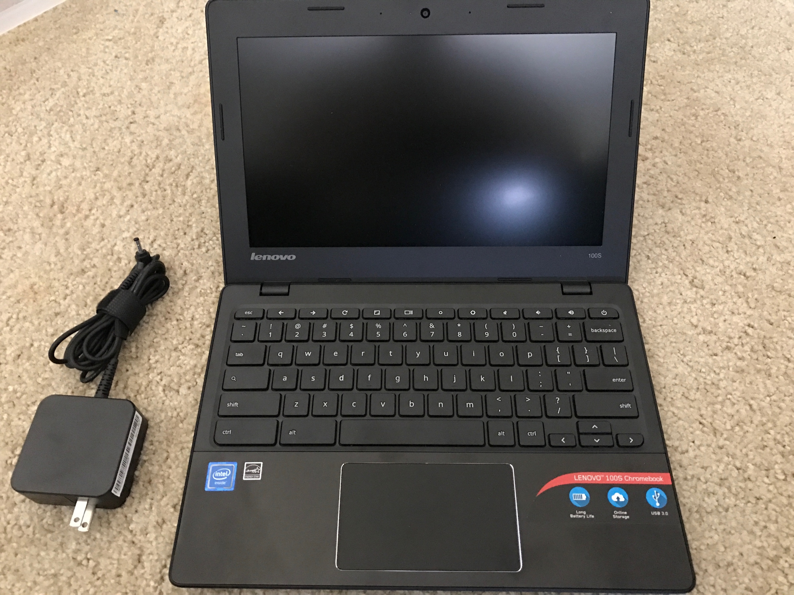

Figure 13 - Chromebook

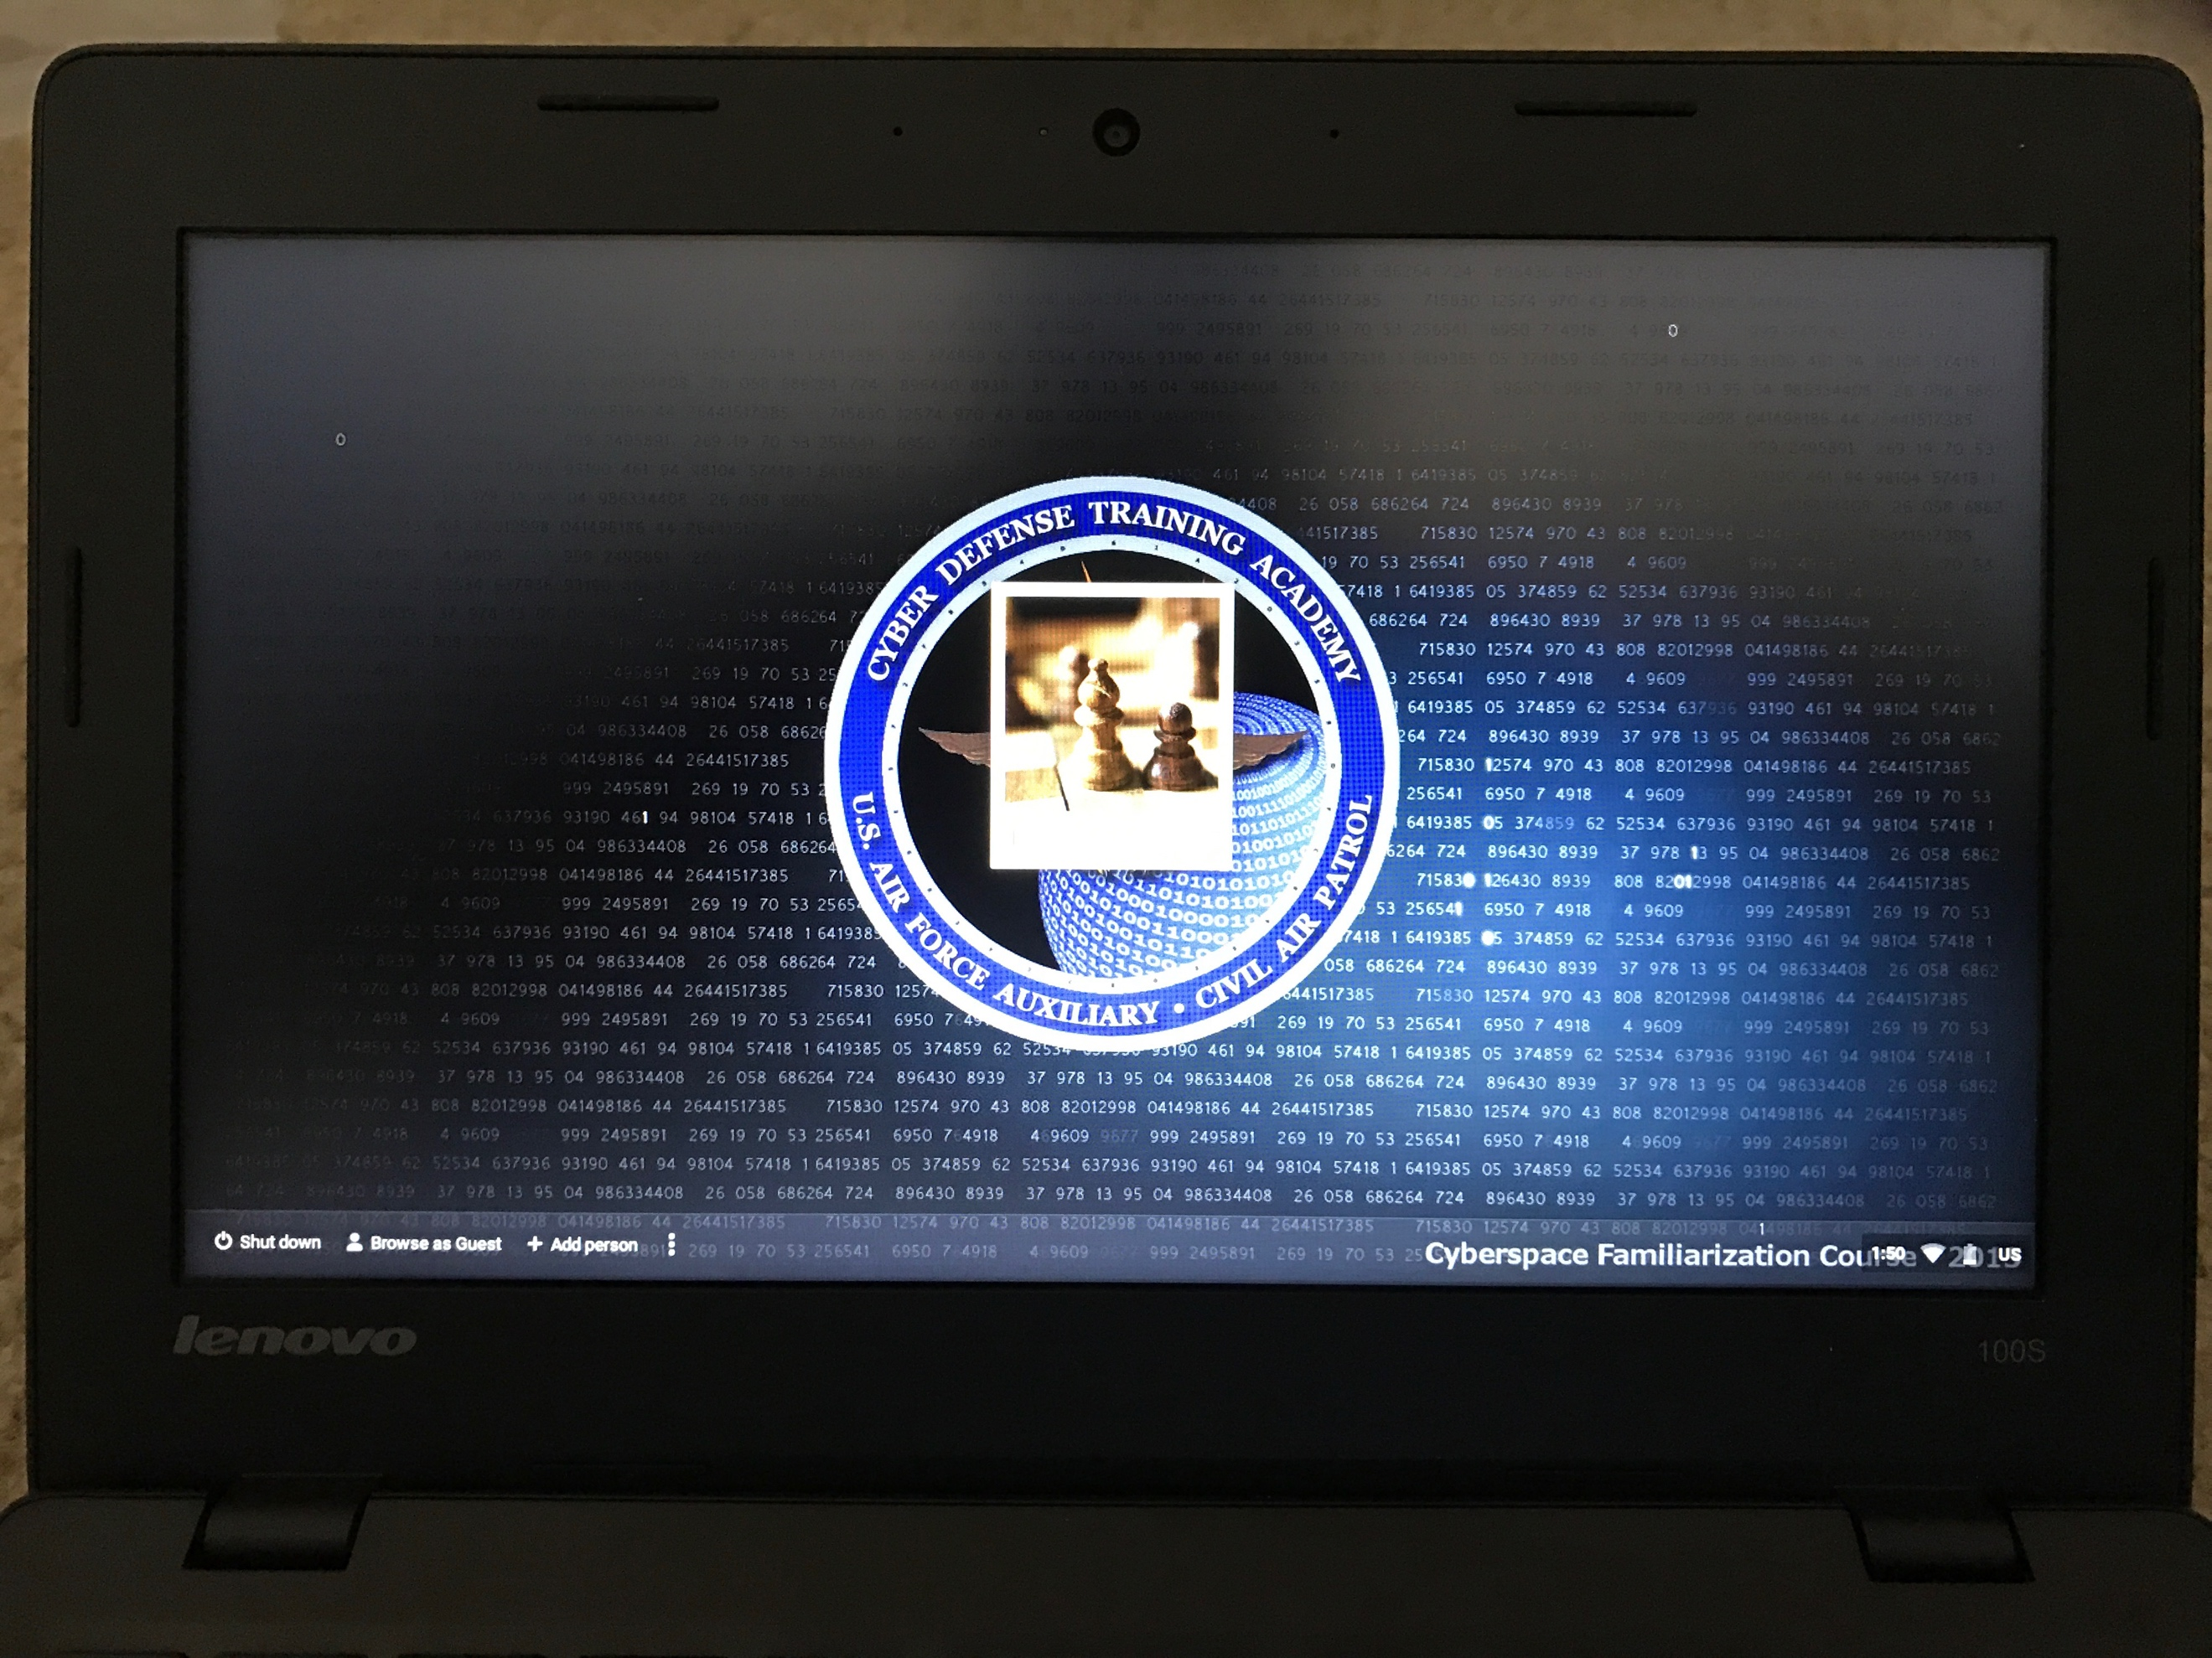

Figure 14 - Chromebook powered on (default screen)

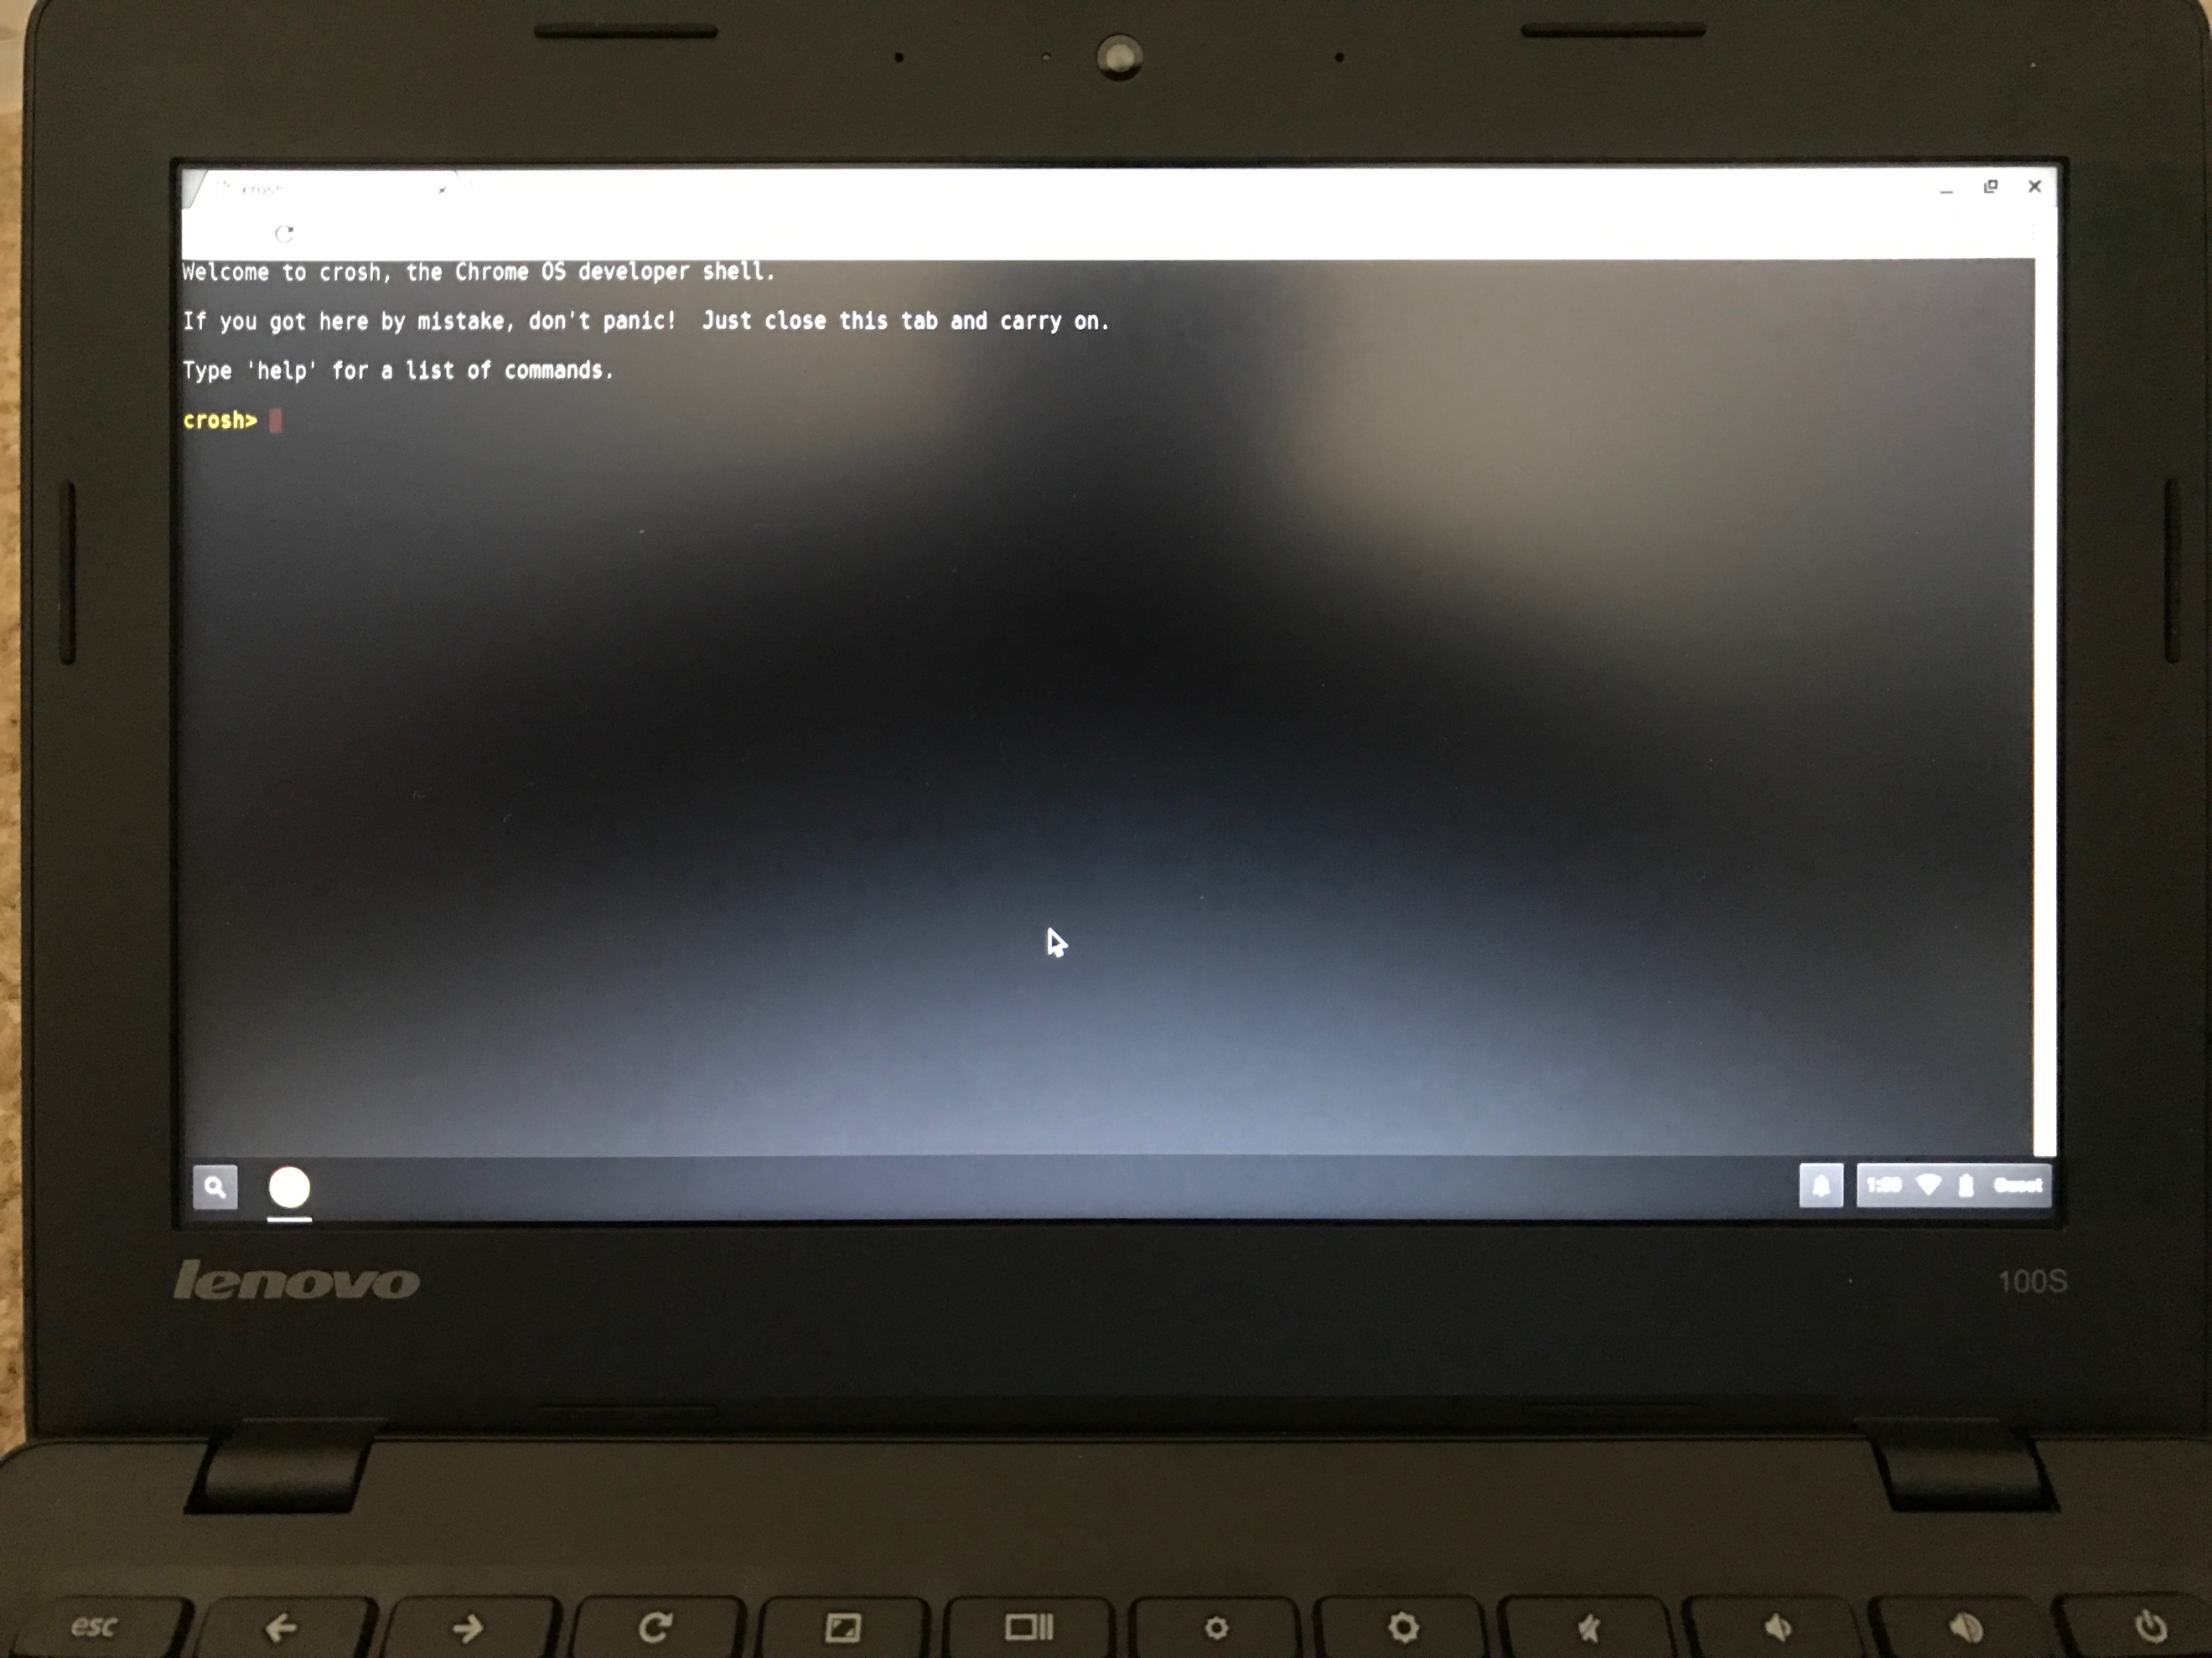

Figure 15 - Click "Browse as Guest" and Press CTRL + ALT + T to access terminal. Type “shell” then “sudo startgnome”

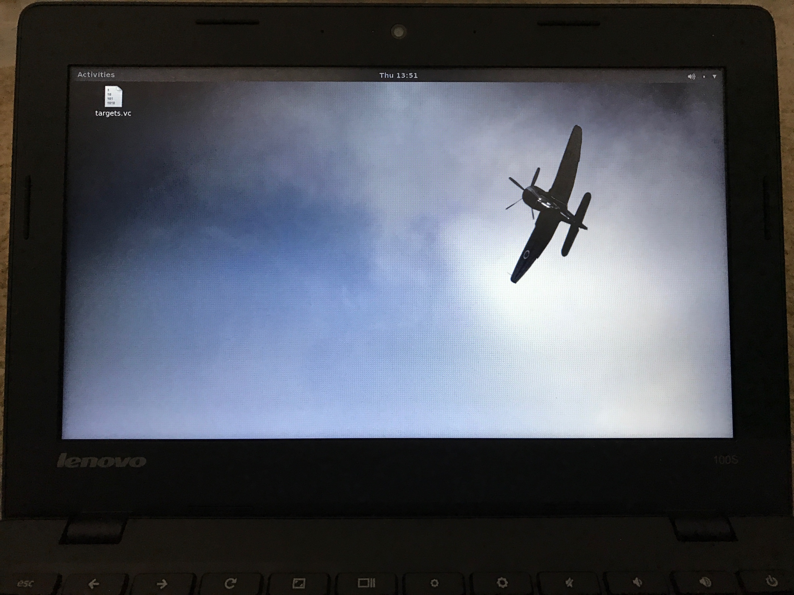

Figure 16 - Linux OS on Chromebook (default desktop). DO NOT GIVE CADETS LAPTOP WITH THIS DESKTOP!!!!! Wait for screen to lock itself out.

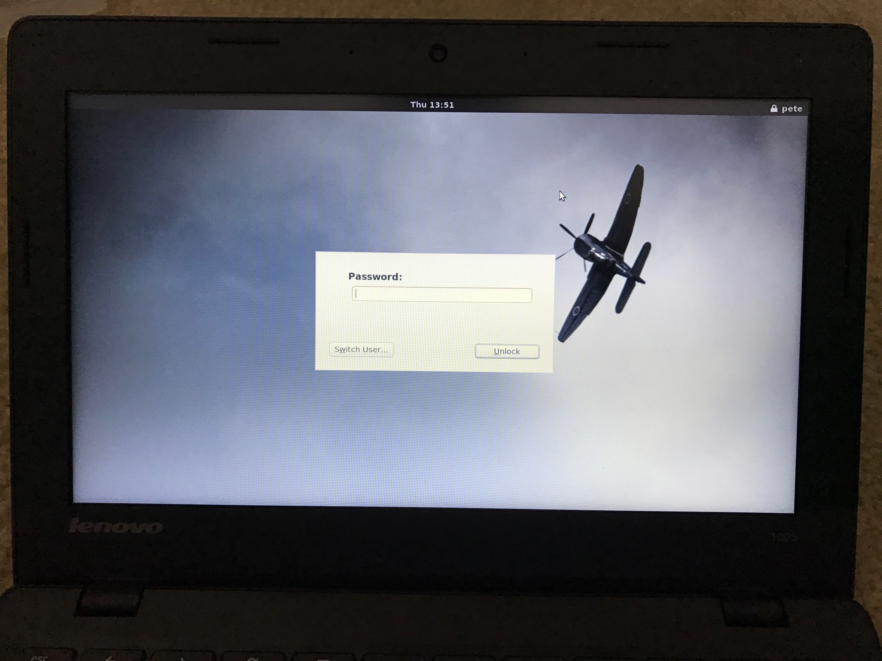

Figure 17 - Linux screen locked.

# ACTIVITY 1 – Cyber Forensics Challenge

**Objective**: Familiarize cadets with forensic concepts, evidence gathering, problem solving and teamwork.

**Introduction:** This activity is designed to familiarize cadets with the processes cyber forensic professionals follow during an investigation. Senior members will use the PBED (Plan, Brief, Execute, Debrief) process to execute this activity with the cadets. This activity is designed to be a competition. Cadets will be broken up into teams of 4-8, briefed on the competition (slides included), execute the competition, and de-briefed on their performance and common pitfalls. It is highly recommended that seniors do not discuss the solution to the scenario until all teams have competed.

**Equipment:**

* Chromebook w/ AC adapter
* Evidence kit
* Clothing sets
* Clip boards for judges
* Cyber Forensics Challenge – Student Form (one per team)
* Cyber Forensics Challenge – Judge Form (one per team)
* Cyber Forensics Challenge – Chain of Custody Form (one per station)
* CDTA Challenge Coins for winners of the challenge

**Pre-competition Tasks:**

1. Plugin Chromebooks to charge the battery
2. Establish a location for the scenario brief and de-brief. It is recommended that this is NOT the competition area
3. Establish a competition area
4. Setup a table for each forensic evidence kit

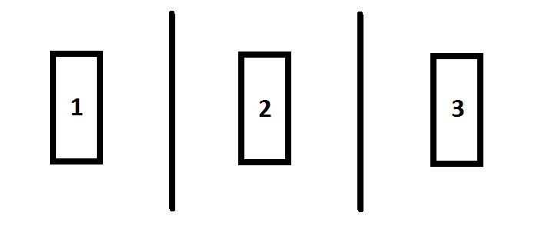

Figure 18 - Competition Layout

1. Setup a wall between each competition area
2. Separate a set of cargo pants, t-shirts, polo shirts and headgear on each table
3. Insert evidence items from each kit into clothing
   1. Use methods like
      1. Inserting passwords in brim of headgear
      2. Inserting password paper in flashlight
      3. Tape SD or flash media on the inside of the clothing
   2. Ensure that all item placement is consistent across all competition areas
4. Carefully fold clothing into an organized pile
5. Open Chromebook and login as **Guest**
6. Press **CTRL + ALT + T** to open a terminal
7. Type the command “**shell**”
8. Type the command “**sudo startgnome**” to start Linux operating system
   1. You should see a screen with a WWII aircraft as the background
9. Wait for the screen to lock
10. Ensure the screen is locked (requires a password) before closing and adding to evidence pile
11. Place one “**Chain of Custody**” form on table
12. Place box of latex/nitrite gloves on a table near competition area. **Do not tell cadets to get gloves. They must do this on their own!**

**Competition:**

1. Handout the Cyber Forensics Challenge – Student Form to each cadet team
2. Have cadets create a team name and input cadet team members
3. Handout the Cyber Forensics Challenge – Judge Form to senior or cadet members that are designated trusted agents for the activity
4. Brief cadets over forensic scenario. Use the **CFC-Inbriefing.pptx** PowerPoint briefing.
5. Execute the challenge within competition area. Give the cadets only 15 minutes to perform all tasks.
6. Have judges assess teams on evidence handling and teamwork
7. Once competition is complete, have cadets leave all forms and evidence on table
8. Remove cadets from the competition area.
9. Have judges tally:
   1. Each properly cataloged evidence item (+10pts each) from Student Form
   2. Access to the computer (+25 pts)
   3. Access to encrypted images volume (+75 pts)
   4. Each discrepancy from Judge Form
   5. Develop total score
10. Rebuild each competition area and reuse Chain of Custody forms for next iteration of the competition

**De-brief:**

1. Discuss findings
2. Ask cadets about issues during the competition
3. Discuss judge’s findings and observations

**Timeline:**

* Brief – 15-20 minutes
* Competition – 15 minutes
* De-brief – 15 minutes
* Total Time – 45-50 minutes

**Activity Completion:**

1. Go over scenario answers
2. Award CDTA challenge coins to the team with the highest score

# Cyber Forensic Challenge Scenario Answers

**WARNING**: This page contains answers to the forensics scenario. Do not discuss these items with competitors prior to all teams competing

## Evidence Collection

Cadets must properly collect and catalog the following items:

* Chapstick, black label, opened
* SanDisk 8GB SDHC card, blue
* SanDisk Cruzer Blade 8GB USB drive, varied colors
* Disney Minion 8GB USB drive, 2-pieces
* Kids eraser, dolphin, whale or penguin
* PaperMate InkJoy pen, white
* Penlight w/ 2 AAA batteries, gold, silver, or grey
* Business card; side one: “~SCAN ME~” words, side two: QR code to a YouTube website w/ Rick Astley “Never Going to Give You Up” video (Rickrolled)
* Cyber Defense Training Academy Challenge Coin; side one: silver, side two: gold
* Piece of paper #1; side one: “S2xuQ%!j”, side two: “1”
* Piece of paper #2; side one: “#fKbz6W*”, side two: “2”
* Piece of paper #3; side one: “b!7dPskpfl%9Q*@L”
* 1x pair of camo pants, size XS/XS
* 1x t-shirt, black, size medium, Cyber Defense Training Academy patch on front, IPSecure patch on back
* 1x 5.11 polo shirt, blue grey or green, size x-large
* 1x 5.11 baseball cap, black or grey

## Scenario

1. Cadets should find and catalog all evidence
2. Cadets should use paper with “b!7dPskpfl%9Q*@L” password to access system
3. Cadets should view pictures on SD card. Pictures do not have value in the investigation.
4. Cadets should view contents of SanDisk Cruzer Blade USB device. Two programs can be seen: **Keepass** and **Veracrypt**. This is possible evidence that the Person of Interest installed these on their laptop.
5. Cadets should view contents of the Minion USB drive. A Keepass password file called “mystore.kdb” can be accessed
   1. Open this file with Keepass
   2. Combine the passwords from piece of paper #1 and #2 and use this as the password for the mystore.kdb file
   3. Copy the “Target Password (Veracrypt)” password “u2$qO*3CP8HVUcoR”
6. On the Chromebook, click “Activities” at the top left and search for VeraCrypt
7. Click “Select File” and navigate to the “targets.vc” file
8. Click mount and enter the password recovered from the KeePass store
9. Enter administrator password from piece of paper #3 to mount the device.
10. Open one of the pictures using ImageMagick (default)
    1. Right-click (click bottom corner of mousepad) and click “Image Info”
    2. Scroll down to GPS coordinates
    3. Copy GPS coordinates and use an online program to determine location
    4. Cadets must give the exact city and state of the photos

## Discussion Points

1. Did you try to brute force the password? Why?
2. Did you find the numbers on piece of paper #1 and #2? Did you think this had a purpose?
3. What was on the SanDisk Cruzer Blade USB device? Did you think that this was a transfer drive? Did you think that the programs on the device could’ve been installed on the laptop?
4. Did you find the USB drive in the Minion? Did you associate the mystore.kdb to KeePass?
5. Did you waste time trying to open the “targets.vc” file? Were you using the right program to open it (i.e. VeraCrypt vs KeePass)? Why wouldn’t KeePass work to open this file?
6. What evidence was not relevant to the investigation?

# ACTIVITY 2 – Cyber Threat Defender Card Game

**Objective:** This activity is designed to familiarize cadets with cyber asset management, threat enumeration and mitigation.

The game is played until a player obtains at least 30 points. If both players reach 30 points during the same round, then the player with the highest total wins. If both have the same total after reaching 30 points in the same round, the game continues until one player reaches 40 points. If a tie still exists, then the game is declared a draw

**Introduction:** In Cyber Threat Defender (CTD), the Cyber Security Collectable Card Game, your goal is to build your network as quickly as possible so you can “do more business” and gain more points. While you are doing this, you have to remember to defend your network because your opponent is going to try and disrupt your systems and network. For every attack there is a defense. For every defense there is an attack to get around it. The player with the most complete set of security defenses will be the one who is able to protect the critical systems and emerge victorious.

**Equipment:**

* you will need to have paper and pencil, or some other way to keep track of scores.
* all players will need to have their own CTD deck of at least 50 cards.
* players may add to their CTD deck by way of booster cards. Customizing is allowed.

**Tasks:**

1. Each player 1 Desktop and 1 ISP card face up on the table to start their network
2. Players then shuffle the rest of their cards and deal themselves 7 cards. The remaining cards are placed face down in the Draw Pile. A Discard Pile will be placed next to the Draw Pile when a card is discarded.
3. Decide who will go first
4. A player can play up to 3 cards of any combination of attack, defense, or asset. A maximum of only 2 of any one card type can be played in a turn. Event cards can be played at ANY time.
5. At the end of a turn, the player draws down to at most 5 cards before drawing 2 cards from their draw pile. Thus, if a player has 6 cards in their hand, they must discard 1. If they have 7 they must discard 2. The discard is done BEFORE they pick 2 cards from their draw pile.
6. If a player's draw pile becomes empty, the player picks up and shuffles their discard pile then places it face down as the new draw pile.
7. A round consists of one turn for each player. At the end of the round, scores are tallied.
8. **CRITICAL SYSTEM FAILURE**: At the beginning of any turn, a player can declare "CRITICAL SYSTEM FAILURE". The player then picks up all of their cards and begins again. No points are lost but the player has to start with just one ISP and one Desktop. The opponent's cards placed on the player are picked up and placed in the opponent's discard pile. This can be done only once per turn.
9. **SKIPPED TURN**: If your turn is skipped, or a card states you receive no points this round or turn, you do not receive any points for assets that you own this round. If you've played a card on an opponent that provides your points (such as a Phishing attack card), you may still gain these points at the end of the round as normal.

**Timeline:** Initially games will take longer to familiarize cadets with rules. Subsequent games should not take more than 30 minutes.

**References:** Please read the “Cyber Threat Defender” card game rules for more detailed operations of the game.